**Use of information communication technology (ICT) based learning tools for effective teaching learning processes;**

Information and Communication Technology (ICT) in education is the mode of education that use information and communications technology to support, enhance, and optimize the delivery of information. In Sri Siddhartha Dental College, ICT has led to an improved student learning and better teaching method. It has been a way to improve the quality of education and make use of efficient technology in our institution.

The various ICT based learning tools for effective teaching learning processes we follow at SSDC include:

* Smart Class

The smart class in SSDC has been set up in place for effective interactive Teaching – Learning. The smart class is equipped with high resolution multicolor LCD projector which has a contrast ratio of 15000:1 and has a HDMI port, the projector is equipped with Wi-Fi connect that makes it user friendly. The Interactive smart board with a 4 point multi touch feature makes the class more interesting and realistic with presentations using ActivInspire software. The multimedia speakers helps in playing audio and sounds that simulate a live environment for the students that helps them to understand the topic better.

Use of applications such as Cisco Webex which is the leading enterprise solution for video conferencing, online meetings, screen share, and webinars is used to share the screen of smart board so all students can view and record the live class for additional reference.

* Use of PowerPoint presentation

SSDC encourages both the students and staff to use PowerPoint presentation for conducting classes/seminars. Innovative PowerPoint Presentations which include pictures, flowcharts, GIF’s, animations and hyperlinks are used by staff to teach the students effectively. The post graduate students use PowerPoint presentations to present their seminars and journal clubs, the postgraduate students use PPT as an effective means to communicate in inter-departmental meets. The undergraduate students are encouraged to conduct classes using ppt’s to share their knowledge and to develop headship under the guidance of staff.

* MCQ classes

The interns of SSDC are benefited with the MCQ classes which are conducted by the staff using ppt as a teaching tool every month Monday to Friday. The content of the presentation includes multiple choice questions with explanatory answers. Problem solving by understanding the subject, abstract thinking and elimination of choices is best explained by this means.

* e – Learning

The e-Learning programme is a great initiative from Sri Siddhartha Dental College and Hospital.

The college has incorporated an e-learning section in its website [http://www.ssdctumkur.org](http://www.ssdctumkur.org/) and the link to the same is <http://www.ssdctumkur.org/e-learning.html>.

The e-learning programme contains various videos created by the college staff that are uploaded on the website under e-Learning section which can be easily accessed by the undergraduate and postgraduate students. Most of the content in e-Learning section are demonstrative videos which helps enhancing learning experiences and providing new sets of skills to the students. The section also contains external links that help in understanding the subject better.

* Live streaming of demonstrations:

Another milestone in ICT section includes the Online streaming of clinical procedures and demonstrations, which is set up in all the departments of Sri Siddhartha Dental College. The live demonstration of clinical/ educative procedures are recorded live in a DSLR or mobile camera and is casted on to a laptop through a Wi-Fi interface, the laptop is connected to the projector through a VGA or HDMI cable and projected in the live class rooms simultaneously. This facilitates a small/medium or even a larger group of students to understand the most skill based procedures easily.

* Use of meeting application during COVID Crisis:

Online meetings with students are made using Webex and Zoom application to conduct online classes/seminars/webinars so as to fill the lacunae of TLE.

**POWERPOINT PRESENTATION**

**SELF-DIRECTED LEARNING**

**MEETING APPLICATION**

**LIVE STREAMING OF DEMONSTRATIONS**

**E – LEARNING**

**MCQ**

**CLASSES**

**Information Communication Technology (ICT) – A Student**

**Centered Approach**

**Information Communication Technology (ICT)**

**A Student**

**Centered Approach**

**Smart Class**

* **Innovative teaching**
* **Realistic teaching approach**
* **Live recording of classes**
* **Webinars**

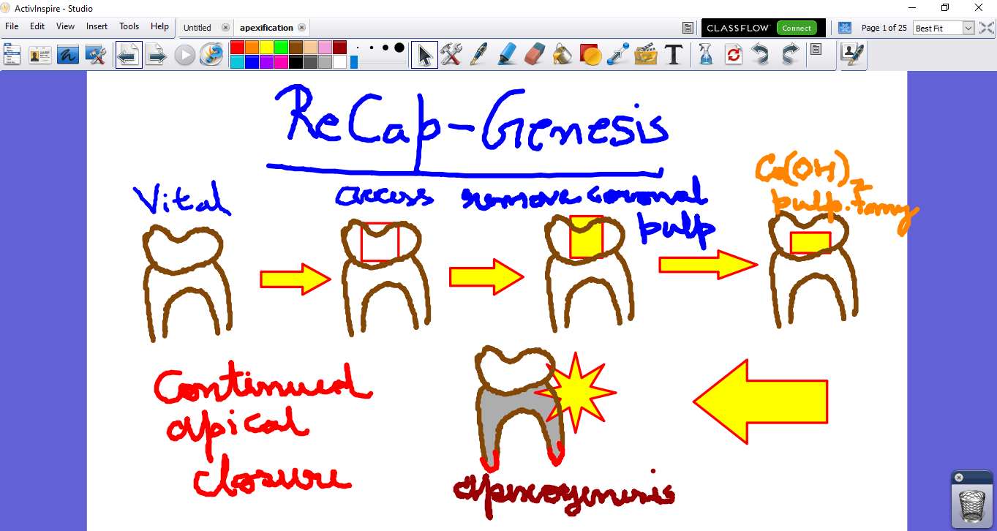

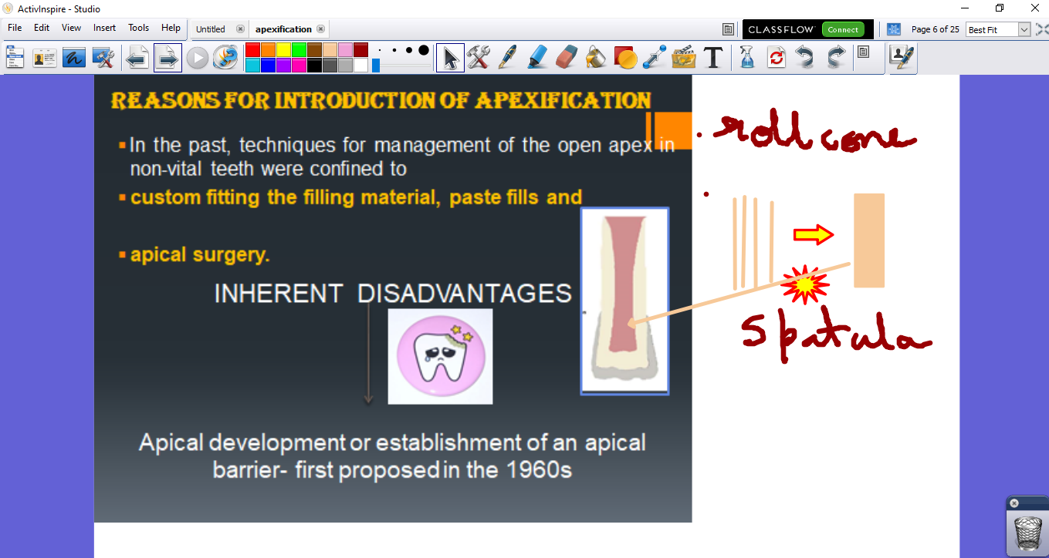

Smart Class Room

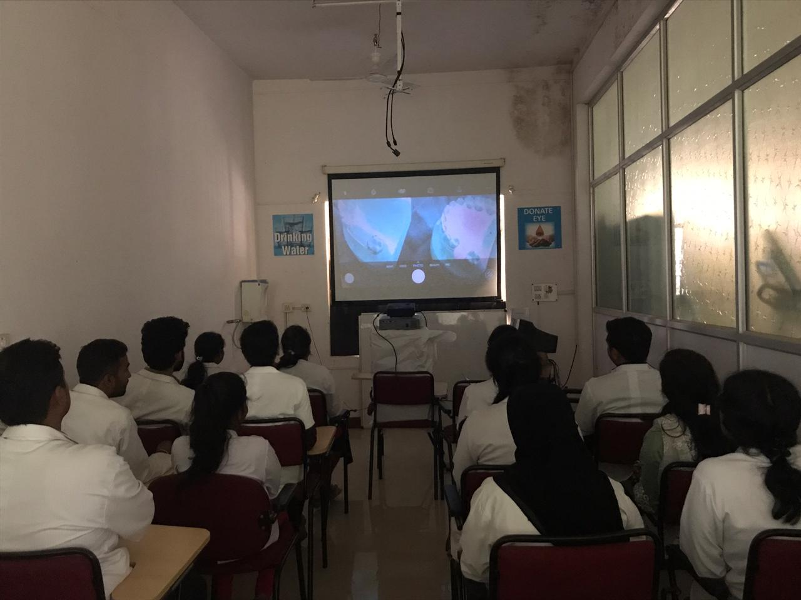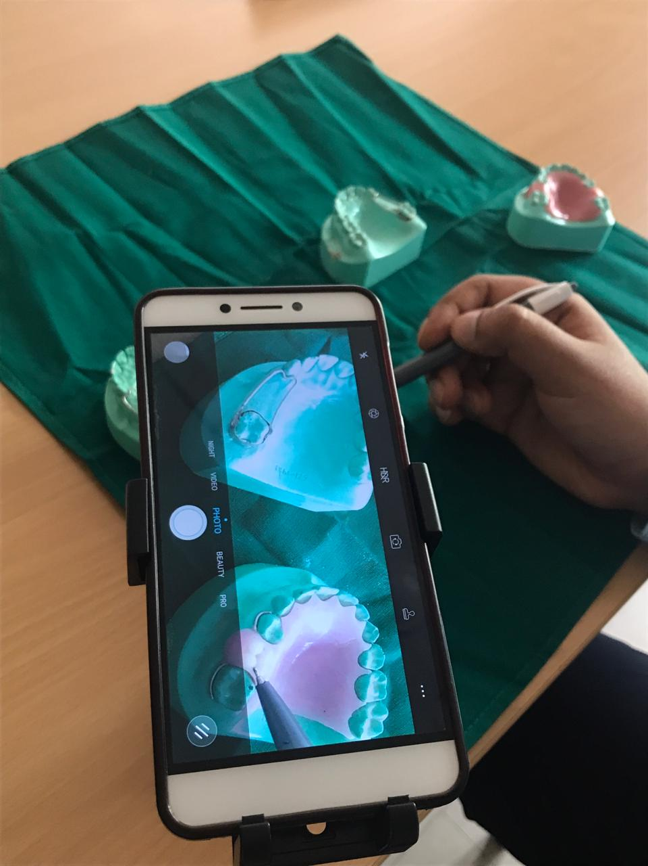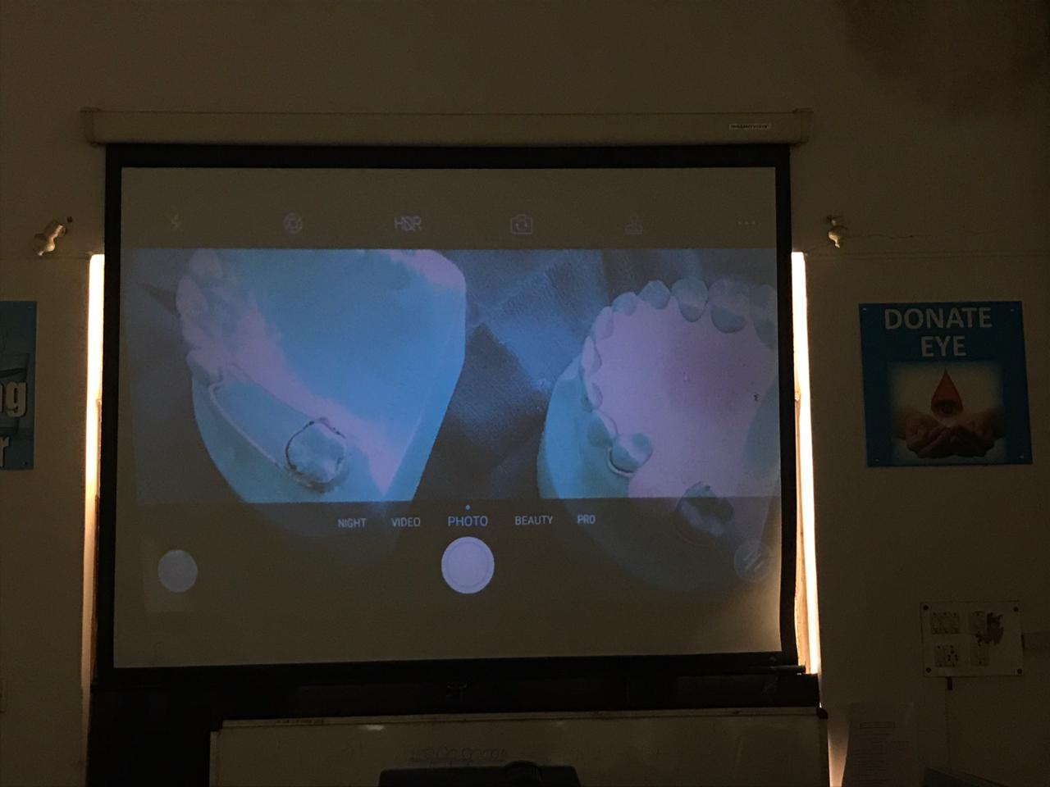

Online Streaming of Classes